Genetics Test Study Guide
- What do you call two similar chromosomes that you inherit from your parents (one from your mother, one from your father)?

- In humans, meiosis produces cells with how many chromosomes?

- In humans, what cell type goes through mitosis is diploid?

- What is a distinguishing characteristic that can be inherited?

- How would you describe the Punnett square in Figure 6.1?
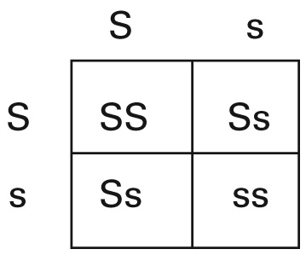
FIG. 6.1
6. How would you describe homozygous alleles?

7. Which Mendel’s law states that organisms inherit two copies of each gene and donate one copy to each of their offspring?
8. What did Mendel do to know that the variations in the offspring generations resulted from his experiments?

9. Which pair of genes in Figure 6.2 would be most likely to be inherited together?
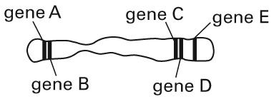
FIG. 6.2

10. What event takes place during anaphase II of meiosis II?
11. Why would recessive alleles not be expressed in a genotype?
12. What does Mendel’s second law of genetics, the law of independent assortment state?

13. What event is an important factor in increasing variety among sexually reproducing organisms?

14. Mendel’s observation that traits are inherited separately was based on which set of experiments?

15. Imagine two heterozygous parents. Each has a dominant allele X for brown eyes and a recessive allele x for blue eyes. What is the phenotypic ratio for brown:blue eyes in their children?

Use the diagram below to answer items 16–20.
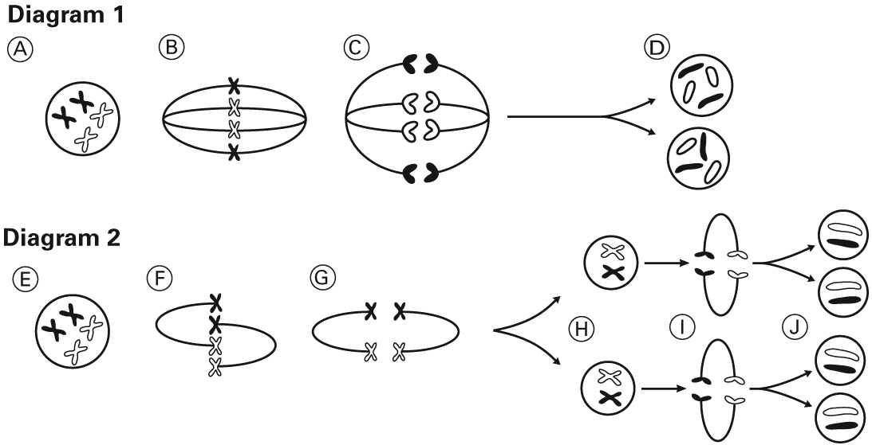
FIG. 6.3
16. Which diagram in Figure 6.3 shows the process of meiosis? How do you know?

17. Identify the process shown in diagram 1. Describe one way the process in diagram 1 is different from the process in diagram 2.

18. Write the letter that corresponds to the part of Figure 6.3 that shows the division of sister chromatids.

19. Write the letter that corresponds to the cells in the diagram that are haploid. How are these cells different from the cells in part D of the diagram?

20. Describe the process shown in part G of the diagram. How does it contribute to genetic diversity in all sexually reproducing organisms?

Use the diagram below to answer items 21–25. (5 credits)
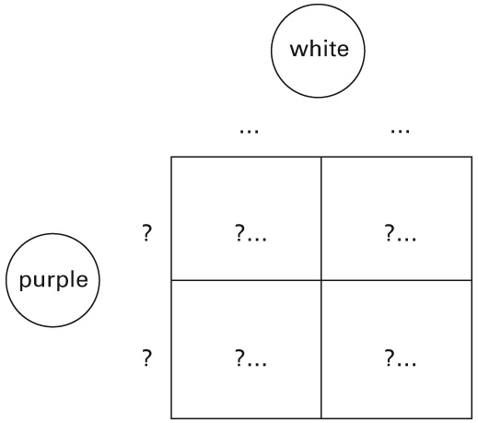

FIG. 6.4
Half of the offspring are purple and half of the offspring are white.
21. Figure 6.4 shows the results of a cross between a plant with a known genotype and a plant of unknown genotype. What is the term for this type of cross?

22. In this plant species, the allele for purple flowers is dominant and the allele for white flowers is recessive. Write the genotype for the offspring that have white flowers.

23. Write the genotype for the offspring that have purple flowers.

24. Predict the genotype for the parent organism whose genotype is unknown. Write a sentence to support your answer.

25. Suppose the genotype of the unknown plants were FF. How would this genotype affect the phenotypes of the offspring?

